**Task 3.7**

Write a query to find the top 10 countries for Rockbuster in terms of customer numbers

select ct.country,count(c.customer_id) as customer_number

from customer c

join address a

on c.address_id = a.address_id

join city ci

on a.city_id = ci.city_id

join country ct

on ci.country_id =ct.country_id

group by ct.country

order by customer_number desc

limit 10;

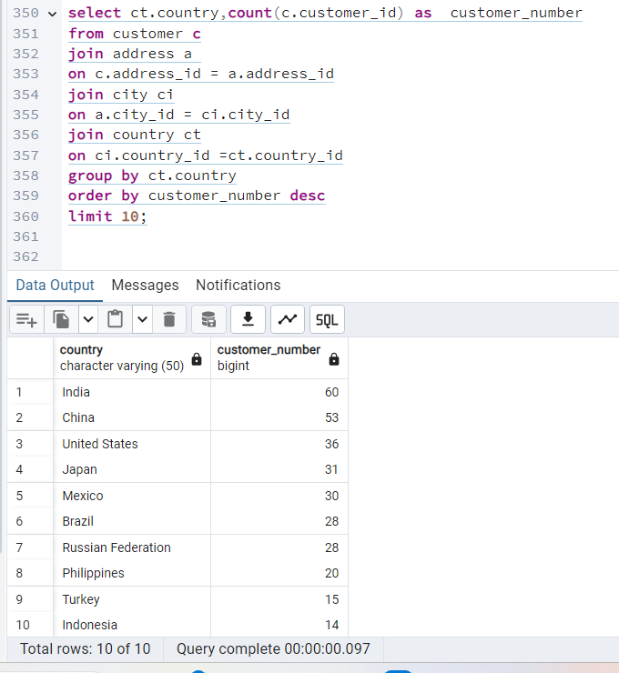

Customer id’s and country are not immediately linked as the tables adress and county are between. First it is important to select the country as we want the top 10 countries by customer numbers. The customer numbers will be calculated by counting customer_id in a new column named number_of_customers. The order of tables for this join syntax is c customer, b address, ci City and ct country. They can only be linked by primary and foreigner keys so this brings us to the order of the join: JOIN address a ON c.address_id = a.address_id JOIN city ci ON a.city_id = ci.city_id JOIN country ct ON ci.country_id = ct.country_id We want the top 10 countries, so next the countries will be grouped. Then the number of customers will be in descending order so the most popular country will be on top. It is important to show the top 10, so the limit is set as 10.

Next, write a query to identify the top 10 cities that fall within the top 10 countries you identified

select ct.country,ci.city,count(c.customer_id) as customer_number

from customer c

join address a

on c.address_id = a.address_id

join city ci

on a.city_id = ci.city_id

join country ct

on ci.country_id =ct.country_id

where

ct.country in (

select ct.country

from customer c

join address a

on c.address_id = a.address_id

join city ci

on a.city_id = ci.city_id

join country ct

on ci.country_id =ct.country_id

group by ct.country

order by count(c.customer_id) desc

limit 10

)

group by ct.country,ci.city

order by customer_number desc

limit 10;

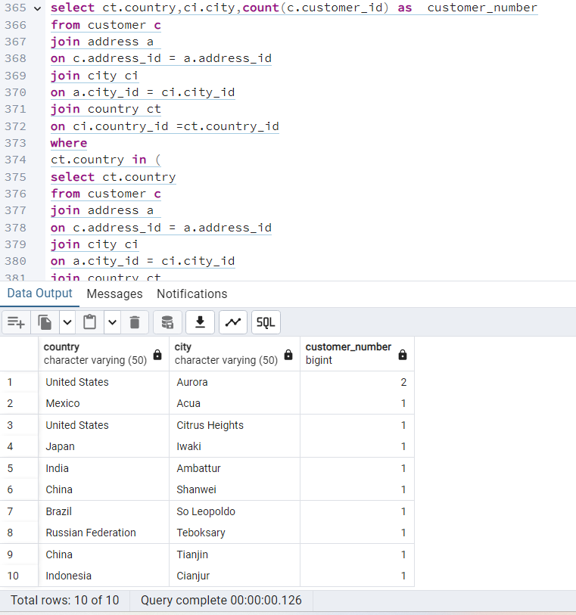

The top 10 countries from last query are important values to add to this current query, that is why we add this join syntax in the WHERE .. IN format. The column of number of customers however only needs to be added in the top 10 cities. So that is why the ORDER BY count of customer id is added after the GROUP BY in the WHERE … IN operater, instead of under SELECT. The join for the top 10 cities is the same as the first query, including country and grouped by country, city.

write a query to find the top 5 customers from the top 10 cities who’ve paid the highest total amounts to Rockbuster.

select c.customer_id,concat(c.first_name,' ',c.last_name) as customer_name,ct.country,ci.city,sum(p.amount) as Highest_total_amount

from payment p

join customer c

on p.customer_id = c.customer_id

join address a

on c.address_id = a.address_id

join city ci

on a.city_id = ci.city_id

join country ct

on ci.country_id = ct.country_id

where ci.city in

(select ci.city from customer c

join address a

on c.address_id = a.address_id

join city ci

on a.city_id = ci.city_id

join country ct

on ci.country_id = ct.country_id

where ct.country in

(select ct.country from customer c

join address a

on c.address_id = a.address_id

join city ci

on a.city_id = ci.city_id

join country ct

on ci.country_id = ct.country_id

group by ct.country

order by count(c.customer_id) desc

limit 10)

group by ct.country,ci.city

order by count(c.customer_id) desc

limit 10)

GROUP BY c.customer_id,ct.country, ci.city

ORDER BY Highest_total_amount DESC

LIMIT 5;

